Docker Task-1

Step 1:

Creating an Ec2 Instance and installing Docker inside the Server

Screenshot mentioned Below:

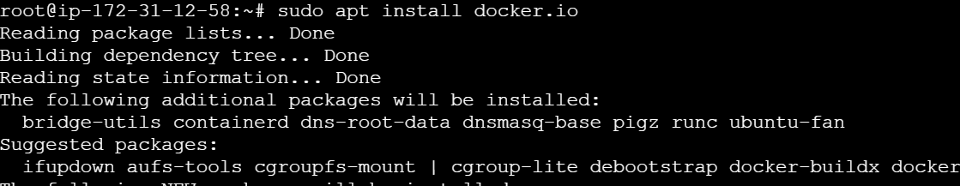

Step 2:

Using the Basic Command of dockers we executed

Docker commands



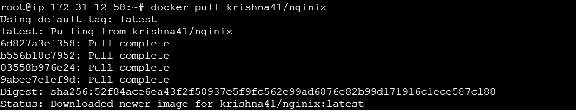

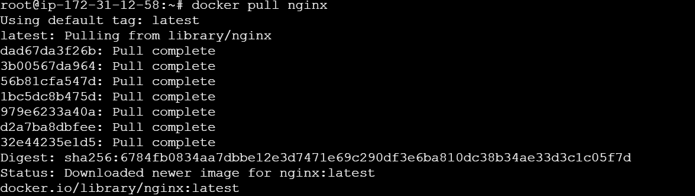

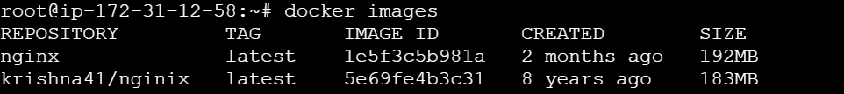

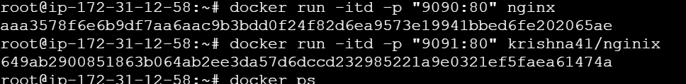

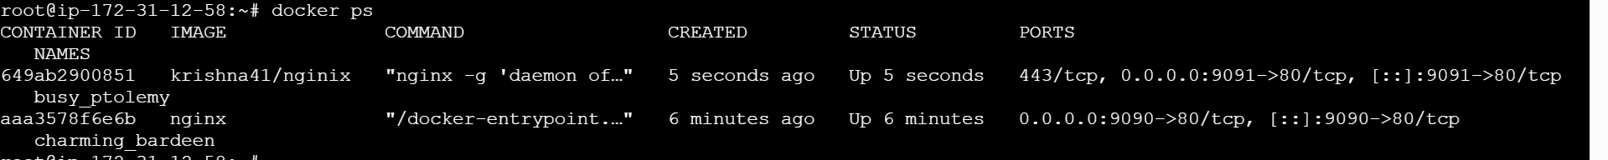

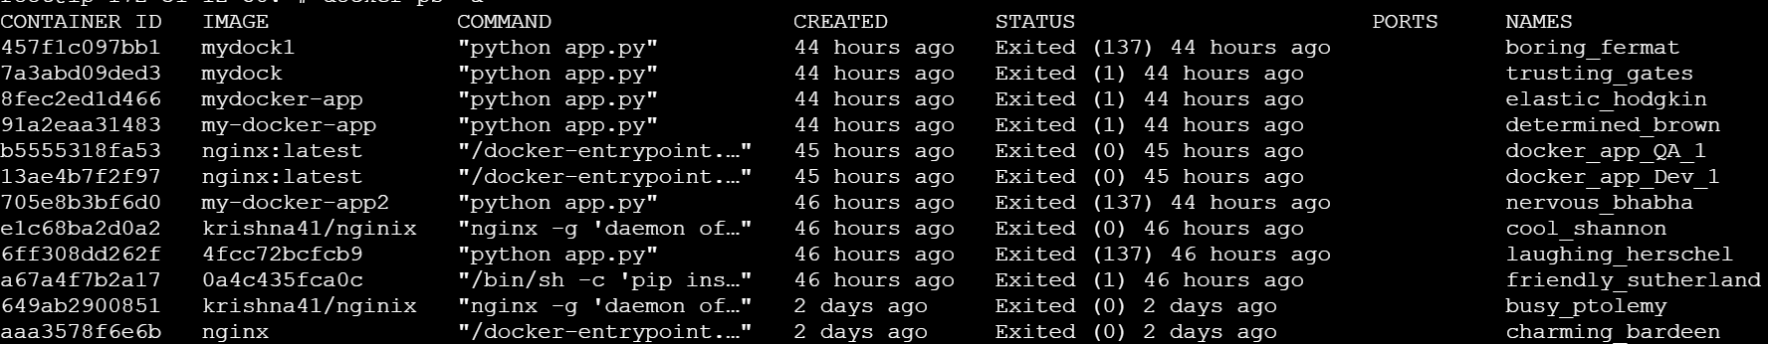

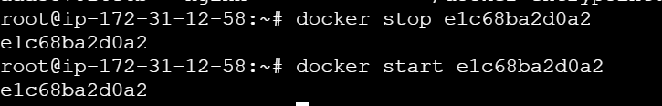

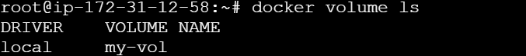

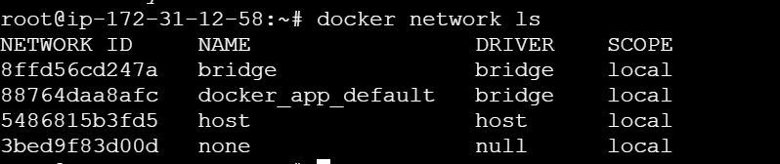

These are the Commands executed in the Dockers

| **Command** | **Description** |
| --- | --- |
| docker run <image> | Run a container |
| docker run -d <image> | Run in background |
| docker run -it <image> bash | Run with terminal access |
| docker ps | List running containers |
| docker ps -a | List all containers |
| docker stop <container> | Stop container |
| docker start <container> | Start stopped container |
| docker restart <container> | Restart container |
| docker rm <container> | Remove container |
| docker logs <container> | Show logs |
| docker exec -it <container> bash | Access inside container |